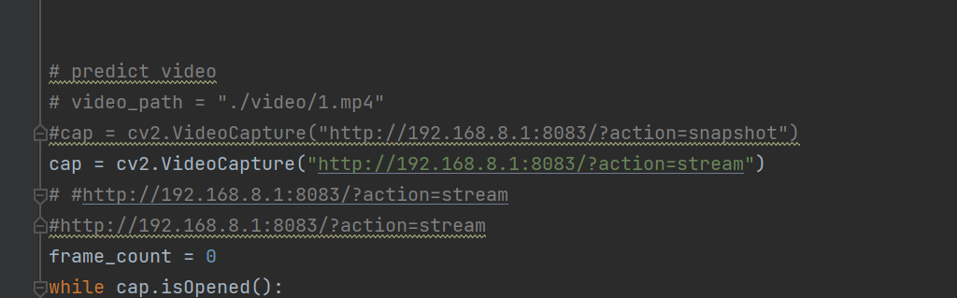Changing the url to video stream address for videoCapture in demo.py and running saveloggings.

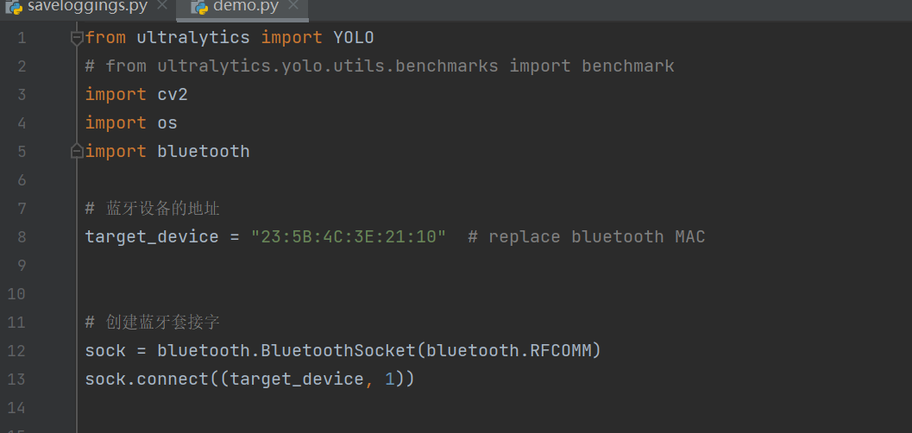

Changing the Mac address for Bluetooth in demo.py and blue,py